CS701 - Theory of Computation

Special Assignment

Marks: 50

Due Date: December 28, 2020

Instructions

The purpose of this assignment is to give your hands-on practice. It is expected that students will solve the assignment themselves. The following rules will apply during the evaluation of the assignment.

- Cheating from any source will result in zero marks in the assignment.
- Any student found cheating in any of the two assignments submitted would be awarded "F" grade in the course.
- No assignment after due date will be accepted through email

Question No. 1 (10 Marks)
Suppose there is a language L and we know that L is Turing-recognizable. Can we say that L is also Turing-decidable? Why or why not?

Question No. 2 (10 Marks)
Consider the following Turing machine M. Give sequence of configurations that M enters when started on the input string 110#01.
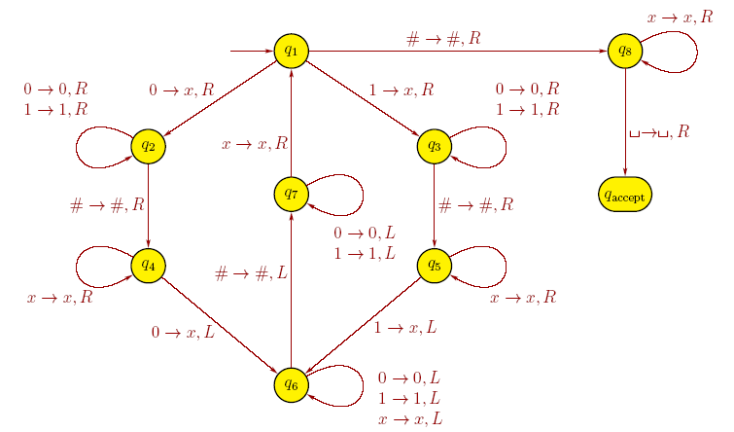

Question No. 3 (15 Marks)
Consider following instances of Post Correspondence Problem (PCP). Is it possible to find a match for each PCP instance given below? If YES, then give the dominos arrangement which will result in a match. If NO, then prove.

- 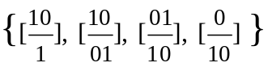
- 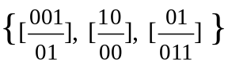

Question No. 4 (15 Marks)
Consider the language A = {0^{k} | k = n² for some n > 0}. Provide implementation level description of multi-tape TM M such that L(M) = A.

